UX Check Results

# Heuristic: Visibility of system status

# Severity: 3

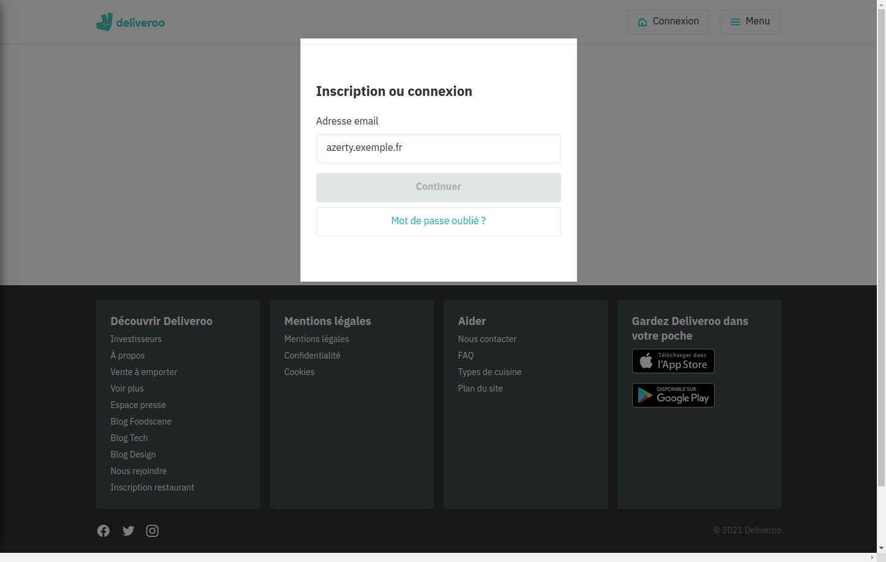

# Notes:

if the email is invalid, the system prevents us from continuing

# Heuristic: Match between system and the real world

# Severity: 3

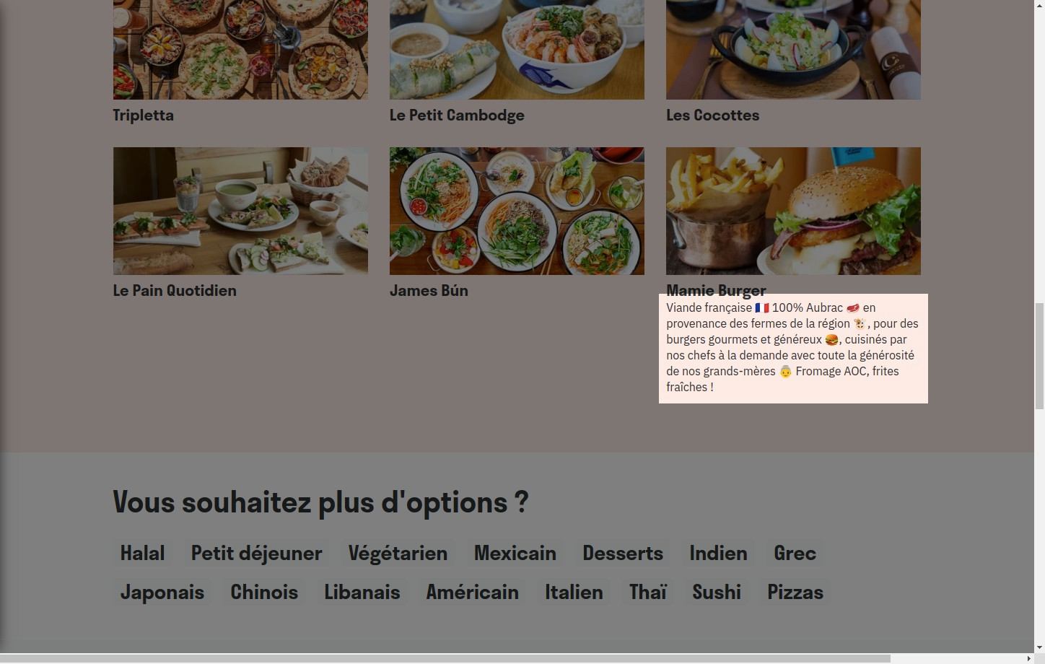

# Notes:

The system uses terms that evoke real life things (farm, burger, cheese, etc.)

# Heuristic: User control and freedom

# Severity: 3

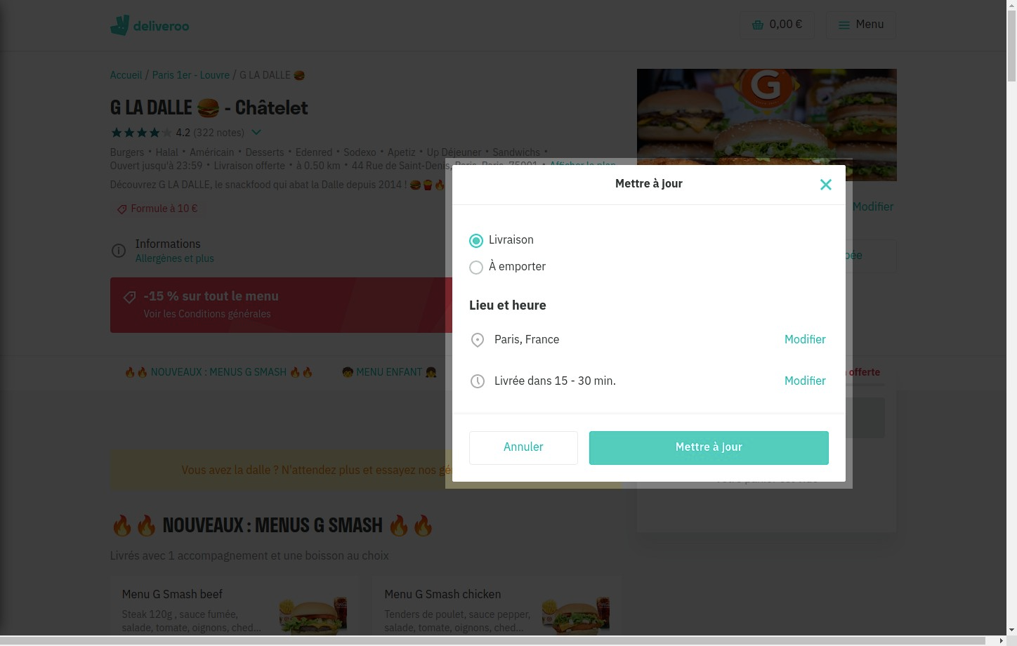

# Notes:

The user can modify his order at any time

# Heuristic: Consistency and standards

# Severity: 3

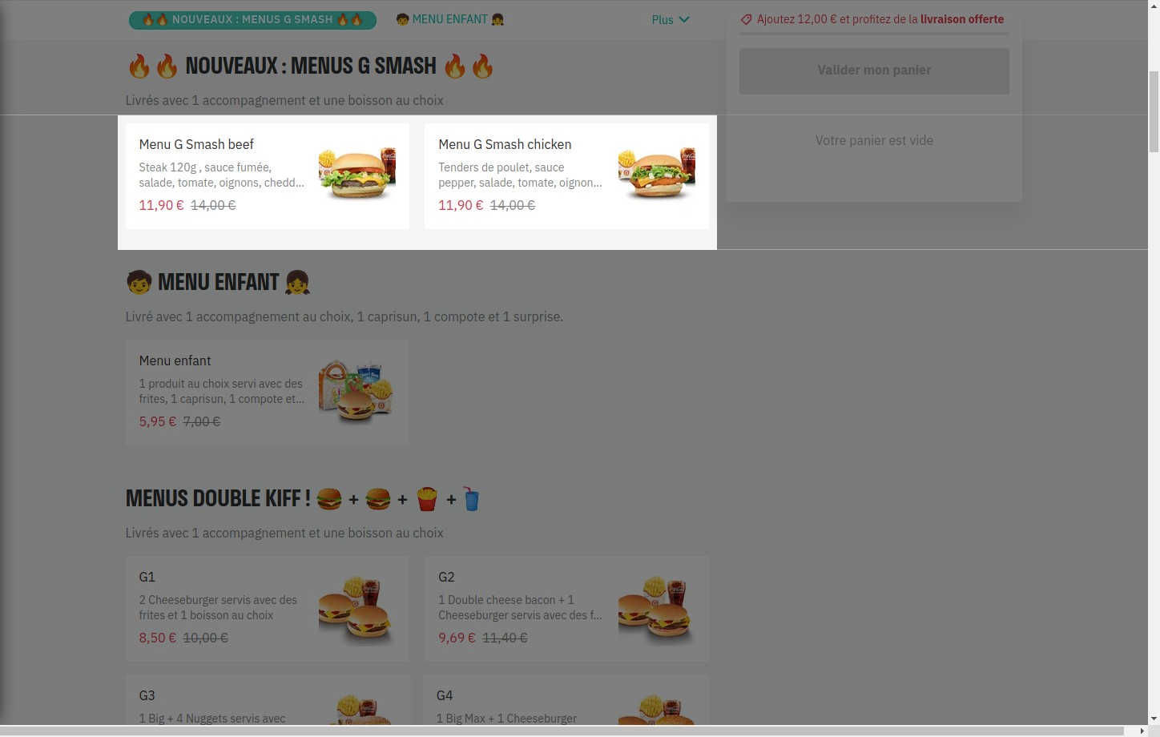

# Notes:

the dishes are all represented in the same way: an image, a short description, a price

# Heuristic: Error prevention

# Severity: 3

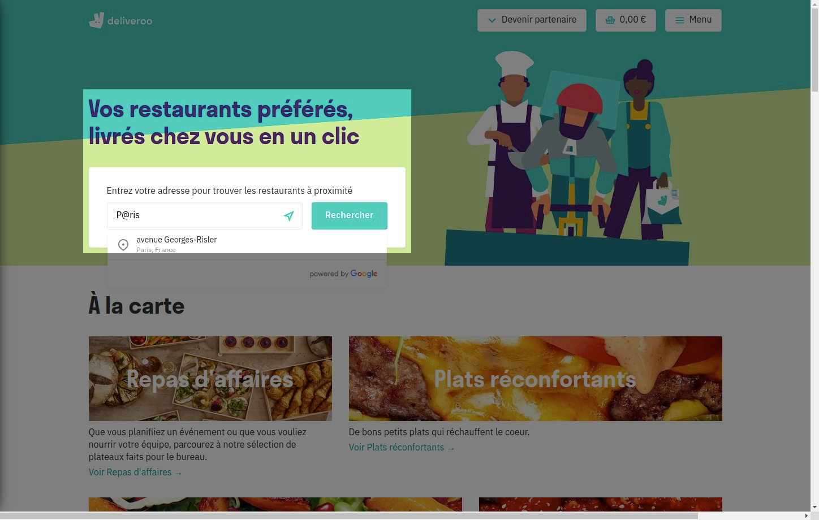

# Notes:

In case of error the system offers us an alternative

# Heuristic: Recognition rather than recall

# Severity: 3

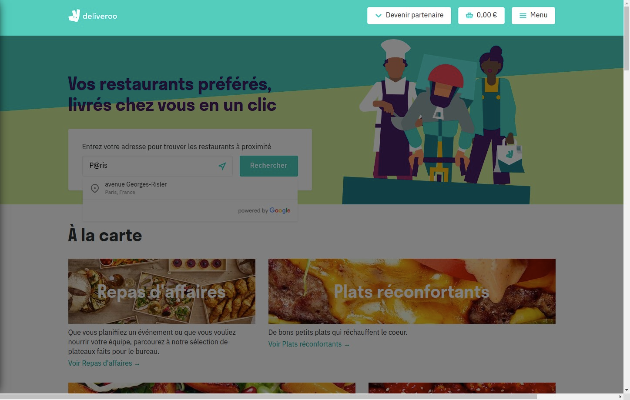

# Notes:

the possible actions are clearly visible

# Heuristic: Flexibility and efficiency of use

# Severity: 3

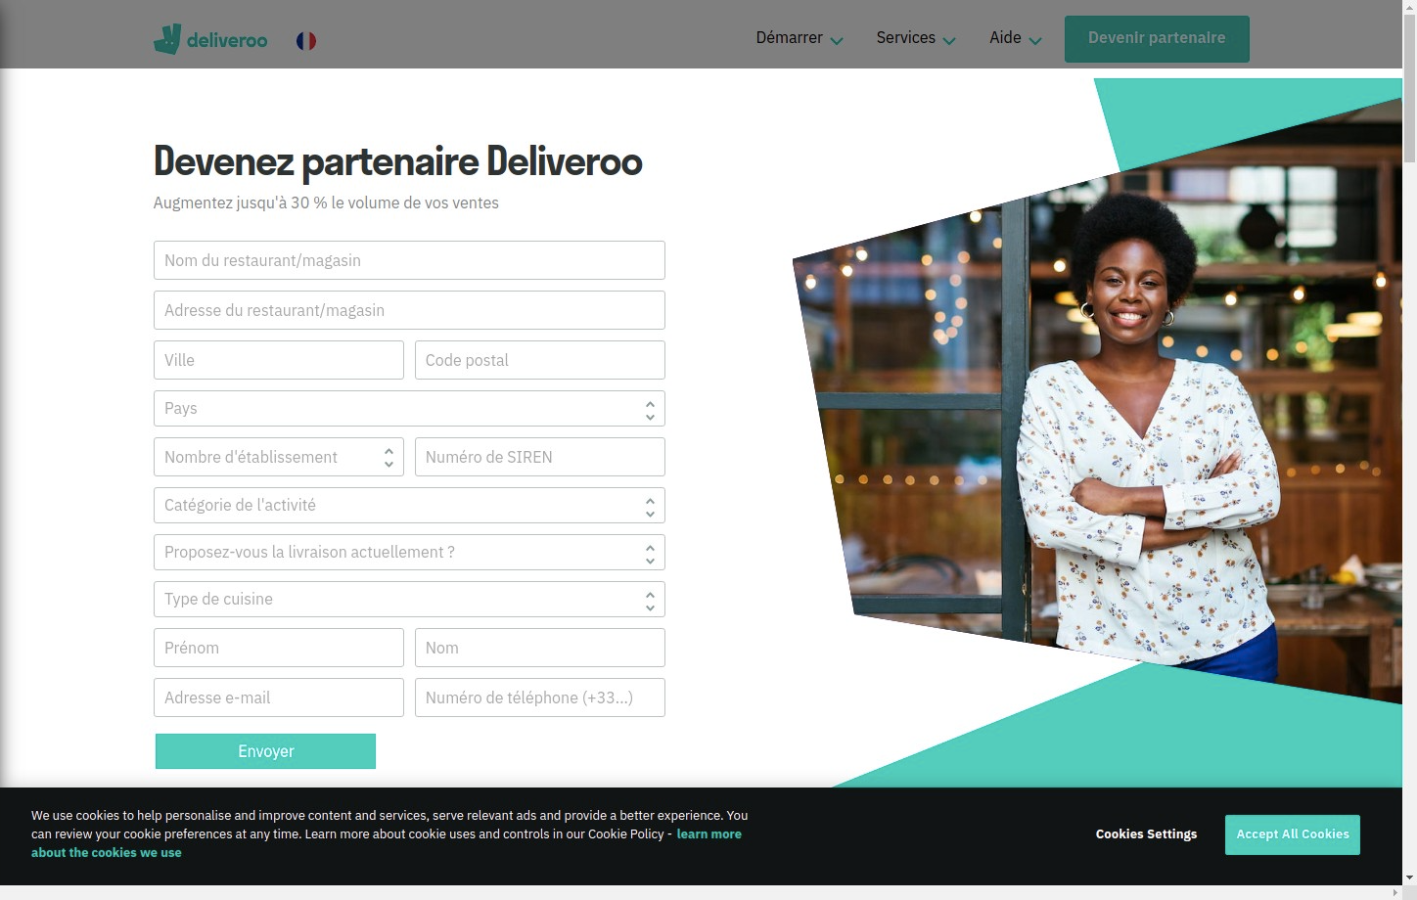

# Notes:

It is quick and easy to become a partner at deliveroo

# Heuristic: Aesthetic and minimalist design

# Severity: 3

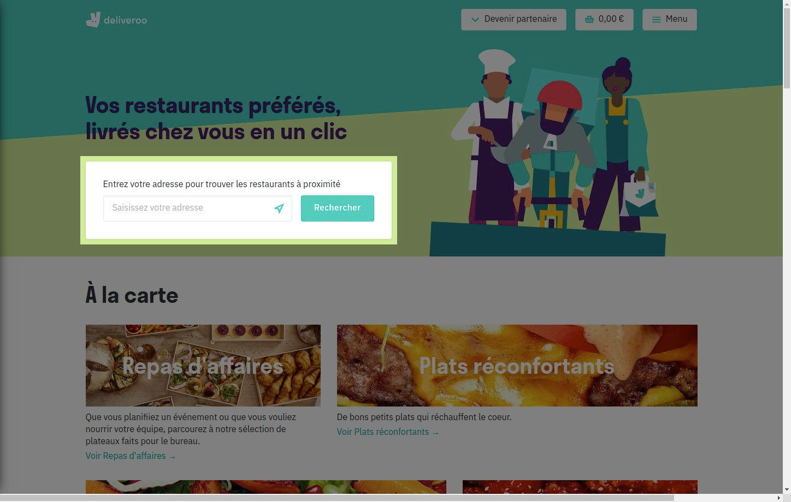

# Notes:

Enter a restaurant, choose a meal and pay. The possible actions are short and quick

# Heuristic: Help recognize &amp; recover from errors

# Severity: 3

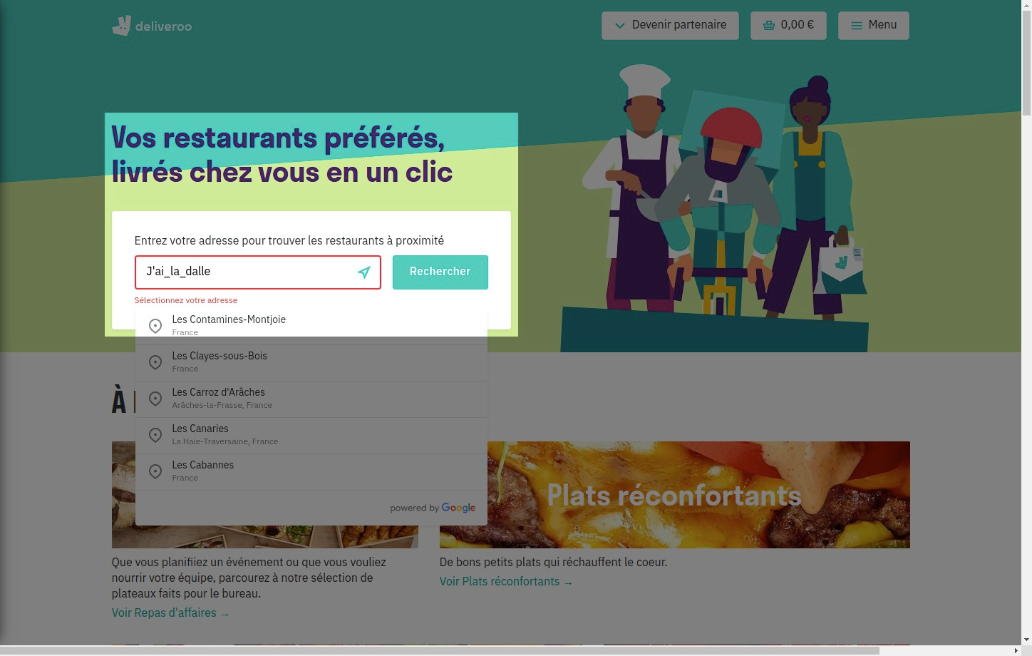

# Notes:

In case of error: warning message in red alternative proposal

# Heuristic: Help and documentation

# Severity: 3

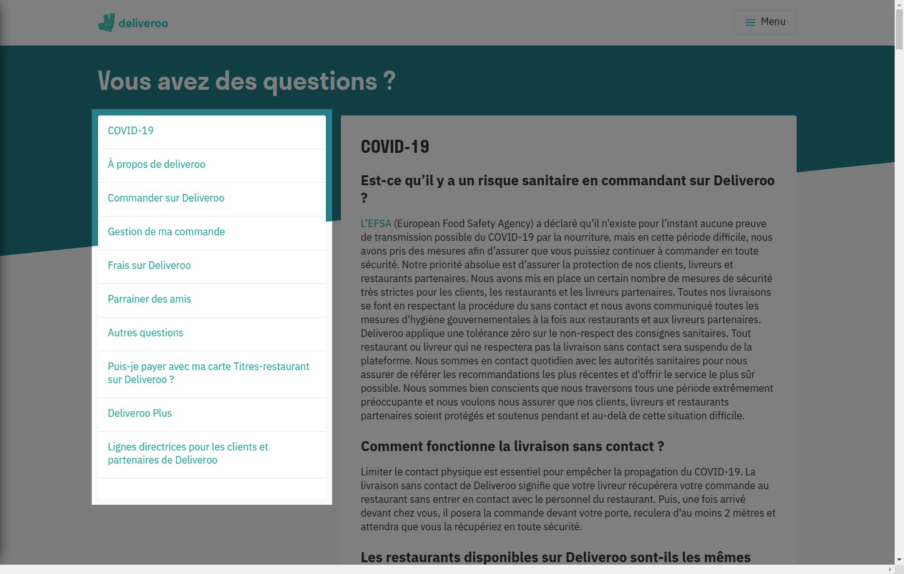

# Notes:

The FAQ has a long list of questions but no support contact form if the user cannot find an answer to their question.